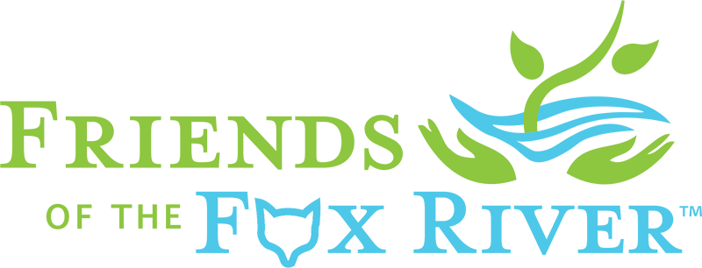
Date
To: (fill in organization contact info)
Friends of the Fox River and (fill in your organization or event partner) invites the (fill in invitee organization) to join us for a river cleanup and community celebration of the Fox River on (fill in date and time at the (fill in cleanup location) in (fill in city or town).
Our first annual Elgin Fox River “Love Our River Day” Cleanup and Community Celebration will start the day by cleaning more than 8,600 feet of the Fox River’s east riverbank between 9am and noon. This year’s cleanup will include a volunteer data collection project as a first step reduce the Fox River’s annual “litter load”.
Following the cleanup, a free public community river celebration will be held on the lawn between the Gail Borden Library and Fox River from 11am to 2pm. Organized Elgin community groups, and the general public are invited to a bring-your-own picnic lunch down by the riverside accompanied by a stage show with live music, demonstrations, exhibits, cleanup awards and contest prizes.
The Fox River has come a long way from the days when it was the most used and abused river in Illinois. Now, with the removal of some dams, improved water quality and increased public access, more fish, birds and people have come back to the Fox. So we think it’s a good time to recognize and celebrate the progress that’s been made.
“We are all friends of our Fox River. Friends help each other in in hard times, and celebrate with them in good times.” said Friends of the Fox River’s President Gary Swick. “Helping to heal our river by removing trash is important. This year, we are inviting Elgin community organizations and residents to join us in a bigger. riverside celebration of our community’s most important resource.”
We hope the (fill in organization) can join us as an organization for this new community event, but if you can’t attend as a group, we hope you will help us reach out to community members to attend. Please feel free forward, print and distribute the attached handout/poster.
For more information, or to register as a group, family or individual, please see the “Love Our River Day” webpage at friendsofthefoxriver.org. You can also call our Executive Director, Gary Mechanic, at 773-590-0710.
Thank you,
(fill in your name, (title optional), and email, phone or preferred contact)
Friends of the Fox River

Friends of the Fox River preserves, restores and protects the Fox River Watershed’s resources by connecting people with nature through education, research, restoration and advocacy.

