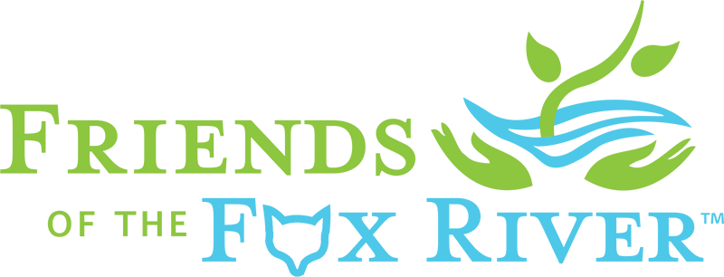
March 10, 2018
Dear,
Thanks very much for volunteering to help at our 2018 Elgin “Love Our River Day” on Saturday, May 12th from 9am to 12noon.
Please check in at the Registration shelter at the west end of Ann Street on the north side of the Gail Borden Library between 8:30am and 9am. Parking is available in the library’s parking lots and on nearby streets. You will be asked to register as a volunteer and assigned to a cleanup team. Children and young adults between the ages of 8 and 18 are welcome, but a parent or guardian must accompany children under 12 years old.
All volunteers will receive a free-boxed lunch following the cleanup. We’ll give you gloves and cleanup tools and assign you (or your group) to a specific stretch of the riverbank. You’ll also receive a brief cleanup and safety training.
Picking up litter and larger items along a river can be dirty work. Please wear work shoes or boots that you don’t mind getting muddy or wet. Please dress appropriately for the weather and bring sufficient water, sunscreen, a hat, and anything else you might need to make yourself comfortable for the three-hour cleanup. We will clean up rain or shine. If the National Weather Service forecasts steady rain or severe enough weather, we will notify all volunteers by email of any event schedule changes before 4pm Friday.
We’re currently evaluating the functionality of several free litter tracking apps. So if you are a “data collection” volunteer you’ll receive an emailed update a week before the cleanup directing you to download the litter tracking app we decide to use.
We encourage all volunteers to plan to stay for our community celebration on the lawn between the library and the river. A stage show will feature live music by the band “Redhorse,” river stories and poems, and awards and prizes for cleanup groups, volunteers and cleanup teams.
Please feel free to email, or call me at the number below if you have any questions.
Thank you again for volunteering to help Friends of the Fox River clean up the Fox River’s banks in Elgin, promote a culture of caring for our river and its watershed, and celebrate the progress we’ve collectively made in cleaning up the Fox River.
Thanks again,
Gary Mechanic, Executive Director
Friends of the Fox River
773-590-0710 (cell 8a to 8p only please)

Friends of the Fox River preserves, restores and protects the Fox River Watershed’s resources by connecting people with nature through education, research, restoration and advocacy.

