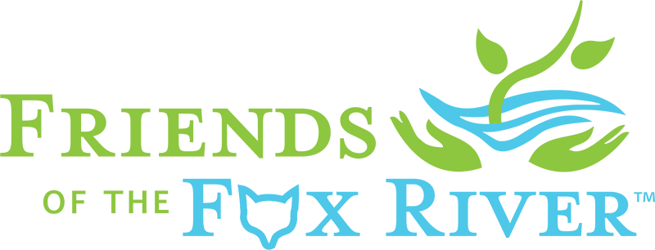

(fill in date)
Dear Friend of the Fox River,
Thank you so much for being a “Love Our River Day” Volunteer.
Your participation was vital in getting the riverfront cleaned up after a summer season of fun along the beautiful Fox River. A total of (fill in number) volunteers made this first ever cleanup of the entire Fox River a success in our community. We picked up a total of (fill in number of pounds of trash or volume of dumpster filled).
We invite you to “Like”, or better yet “Follow”, Friends of the Fox River’s Facebook page, and join Friends of the Fox River as a member. We’ll keep in touch and keep you informed about other opportunities to support our work, and enjoy the river.
Our goal in (fill in your community’s name) is to create a group of local volunteers who will work together throughout the year to plan and produce next year’s “Love Our River Day”. If you are interested in working with (fill in your group’s name) and Friends of the Fox River to produce a bigger and better cleanup and community river celebration next spring, please reply to this note.
Once again, thank you very much for volunteering.
Let’s Keep “Fixin’ the Fox” together,
(fill in your name)
(fill in your contact information)

Friends of the Fox River preserves, restores and protects the Fox River Watershed’s resources by connecting people with nature through education, research, restoration and advocacy.

