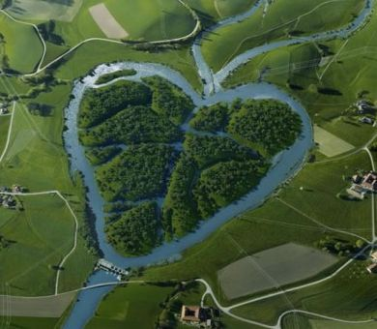  “It’s Our fox River Day”  Community river Celebrations  Saturday, September 18, 2021  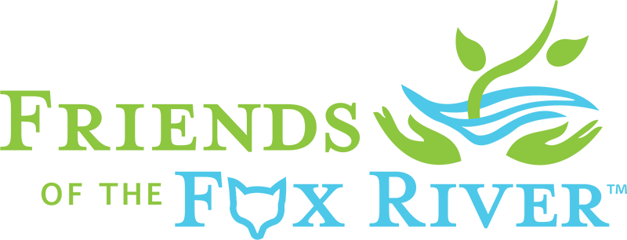  Join your neighbors, local organizations and Friends of the Fox River for the 3rd annual “It’s Our Fox River Day” - community cleanups and celebrations along the entire Fox River from Waukesha to Ottawa.  friendsofthefoxriver.org/Fox River Day | Community Celebrations  ────  Fox River Cleanups  ────  Environmental Education  ────  Locally organized events  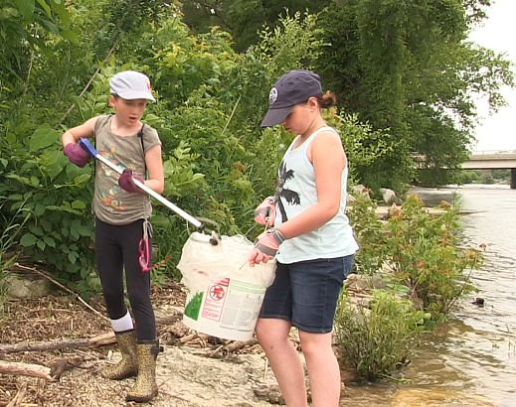  ────  Family Friendly  TO VOLUNTEER VISIT  friendsofthefoxriver.org  Love Our River Days

